Price Mechanism
The invisible hand – the workings of the price mechanism
Adam Smith | Adam Smith, one of the Founding Fathers of economics famously wrote of the “invisible hand of the price mechanism”. He described how the invisible or hidden hand of the market operated in a competitive market through the pursuit of self-interest to allocate resources in society’s best interest. This remains the central view of all free-market economists, i.e. those who believe in the virtues of a free-market economy with minimal government intervention.  The price mechanism is a term used to describe the means by which the many millions of decisions taken each day by consumers and businesses interact to determine the allocation of scarce resources between competing uses. This is the essence of economics!

The price mechanism plays three important functions in any market-based economic system:
The signalling function
The price of digital printing is coming down – this will have an effect on the demand for substitute forms of image printing. How will traditional photo imaging retailers respond?
Firstly, prices perform a signalling function. This means that market prices will adjust to demonstrate where resources are required, and where they are not.
Prices rise and fall to reflect scarcities and surpluses. So, for example, if market prices are rising because of high and rising demand from consumers, this is a signal to suppliers to expand their production to meet the higher demand.
Consider the left hand diagram on the next page. The demand for computer games increases and as a result, producers stand to earn higher revenues and profits from selling more games at a higher price per unit. So an outward shift of demand ought to lead to an expansion along the market supply curve.
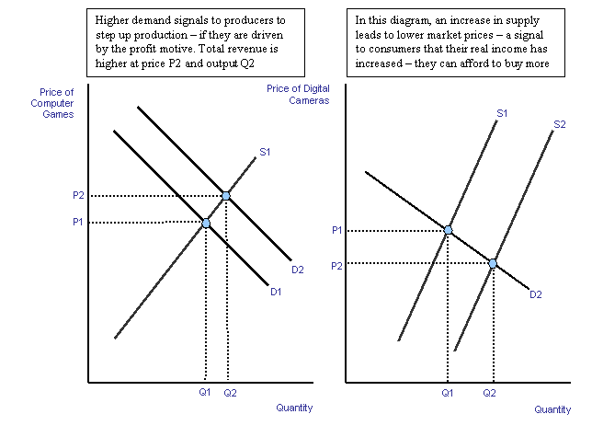
In the second example on the right, an increase in market supply causes a fall in the relative prices of digital cameras and prompts an expansion along the market demand curve
Conversely, a rise in the costs of production will induce suppliers to decrease supply, while consumers will react to the resulting higher price by reducing demand for the good or services.
The transmission of preferences
Through the signalling function, consumers are able through their expression of preferences to send important information to producers about the changing nature of our needs and wants. When demand is strong, higher market prices act as an incentive to raise output (production) because the supplier stands to make a higher profit. When demand is weak, then the market supply contracts. We are assuming here that producers do actually respond to these price signals!
One of the features of a free market economy is that decision-making in the market is decentralised in other words, the market responds to the individual decisions of millions of consumers and producers, i.e. there is no single body responsible for deciding what is to be produced and in what quantities. This is a remarkable feature of an organic market system.
The rationing function
Prices serve to ration scarce resources when demand in a market outstrips supply. When there is a shortage of a product, the price is bid up – leaving only those with sufficient willingness and ability to pay with the effective demand necessary to purchase the product. Be it the demand for tickets among England supporters for the 2006 World Cup or the demand for a rare antique, the market price acts a rationing device to equate demand with supply.
The prices for using the M6 Toll Road are a good example of the rationing function of the price mechanism. A toll road can exclude those drivers and vehicles that are not willing or able to pay the current toll charge. In this sense, motorists and road haulage businesses and other road users are paying for the right to use the road, road space has a market price instead of being regarded as something of a free good. The current charges are below:
Prices on the M6 Toll Road  June 2006 |  | Day  (06:00 - 23:00) |  | Night  (23:00 - 06:00)
Class 1 (e.g. motorbike) |  | £2.50 |  | £1.50
Class 2 (e.g. car) |  | £3.50 |  | £2.50
Class 3 (e.g. car & trailer) |  | £7 |  | £6
Class 4 (e.g. van/coach) |  | £7 |  | £6
Class 5 (e.g. HGV) |  | £7 |  | £6
What would happen if the day-time charges increased to £5 for cars?
The growing popularity of auctions as a means of allocating resources is worth considering as a means of allocating resources and clearing a market. The phenomenal success of EBAY is testimony to the power of the auction process as a rationing and market clearing mechanism as internet usage has grown.
The price mechanism is the only allocative mechanism solving the economic problem in a free market economy. However, most modern economies are mixed economies, comprising not only a market sector, but also a non-market sector, where the government (or state) uses the planning mechanism to provide public goods and services such as police, roads and merit goods such as education, libraries and health.
In a state run command economy, the price mechanism plays little or no active role in the allocation of resources. Instead government planning directs resources to where the state thinks there is greatest need. The reality is that state planning has more or less failed as a means of deciding what to produce, how much to produce, how to produce and for whom. Following the collapse of communism in the late 1980s and early 1990s, the market-based economy is now the dominant economic system – even though we are increasingly aware of imperfections in the operation of the market – i.e. the causes and consequences of market failure.
Prices and incentives
- Incentives matter enormously in our study of microeconomics, markets and instances of market failure. For competitive markets to work efficiently all economic agents (i.e. consumers and producers) must respond to appropriate price signals in the market.
- Market failure occurs when the signalling and incentive function of the price mechanism fails to operate optimally leading to a loss of economic and social welfare. For example, the market may fail to take into account the external costs and benefits arising from production and consumption. Consumer preferences for goods and services may be based on imperfect information on the costs and benefits of a particular decision to buy and consume a product. Our individual preferences may also be distorted and shaped by the effects of persuasive advertising and marketing to create artificial wants and needs.

Government intervention in the market
Often the incentives that consumers and producers have can be changed by government intervention in markets. For example a change in relative prices brought about by the introduction of government subsidies and taxation.
Suppose for example that the government decides to introduce a new tax on aviation fuel in a bid to reduce some of the negative externalities created by the air transport industry.
- How will airlines respond?
  - Will they pass on the tax to consumers?
  - Can they absorb the tax and seek cost-savings elsewhere in their operations?
- If the tax raises price for air travellers, will they change their behaviour in the market?
- Is an aviation tax the most effective way of controlling pollution? Or could incentives for producers and behaviour by consumers wanting to travel by air be changed through other more effective and efficient means?
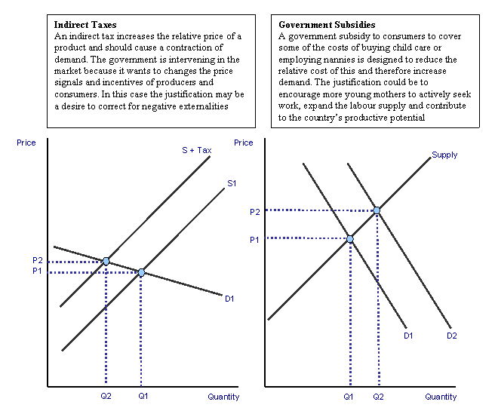
Agents may not always respond to incentives in the manner in which textbook economics suggests.
The “law of unintended consequences” encapsulates the idea that government policy interventions can often be misguided of have unintended consequences! See the revision focus article on government failure.

